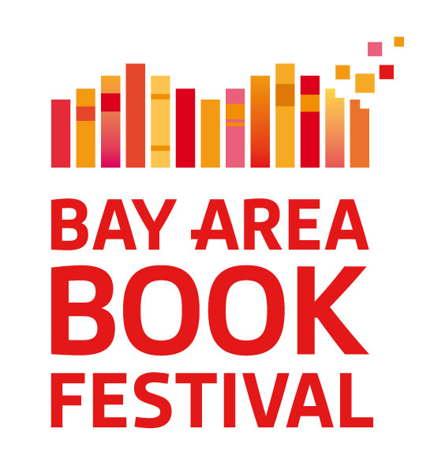
February 1, 2017
REV April 15, 2017

Galvanizing the Resistance via Literature:
Third Annual Bay Area Book Festival, June 3-4, 2017

The Bay Area Book Festival in Berkeley (www.baybookfest.org) is sharpening its mission to focus on literary activism in response to the rise of intolerance and injustice in this country and worldwide. Courageous, insightful, intelligent literary work is an essential tool for resisting these forces. The weekend event—June 3-4, 2017—will gather writers and readers who are committed to tolerance, sanctuary, justice, equality, environmental sustainability, diversity and inclusion—our bedrock values. There is no better place than Berkeley, renowned for its intellectual activism, for an event that highlights literature as a vehicle for social change.

At only three years old, the Bay Area Book Festival has become one of the country’s leading literary events, bringing together tens of thousands of readers with hundreds of the world’s most respected writers for in-person literary exploration and celebration. We have always emphasized writers and books concerned with social justice, diversity and the environment. We now are raising our sign higher in the public square as we explore and amplify the literary voice of resistance.

Great literature is never didactic, but it is inherently activist. Autocrats are threatened not only by what great books say but by the literary form itself. Whether non-fiction, fiction, or poetry, literature allows remarkable access into the subtle lived experience and perspectives of other people and cultures. Literature shapes the most potent and elusive power that humankind has: hearts and minds.

When hearts and minds are mobilized, watch out—as we saw with the public response to The Jungle, Silent Spring, Hiroshima, The Feminine Mystique, The Invisible Man, and thousands of other world-changing books. Legend has it that Lincoln said to Harriet Beecher Stowe upon meeting the diminutive author, “So you’re the little woman who wrote the book that started this great war.”

Great literature respects the intelligence and agency of its readers. It does not use its power for manipulation, which is cynical. Great literature is hopeful. By asking to be read, it assumes human potential. Picking up a book means opening oneself to change. Reading a book (and especially writing one) means believing in the possibility of this change. These changes may be explicit and social, or subtle and intensely private, but they are progressive—as it is defined politically—in being humanist.

Books authorize (literally) voices to be heard, which is why the Bay Area Book Festival places a high priority on writers who come from oppressed communities. We especially emphasize women writers. The Bay Area Book Festival was founded by a woman and is largely led by women.

Statement written by Cherilyn Parsons, founder and executive director. The Bay Area Book Festival is the main project of the Foundation for the Future of Literature and Literacy, a 501(c)(3) nonprofit organization founded for the purpose of the Festival. We do not carry out advocacy but have an educational mission to present a public event that promotes literature and literacy.

